**Ideation Phase**

**Define the Problem Statements**

|  |  |
| --- | --- |
| Date | 19 September 2022 |
| Team ID | PNT2022TMID51719 |
| Project Name | SmartFarmer –IoT Enabled Smart Farming Application. |
| Maximum Marks | 2 Marks |

**Customer Problem Statement :**

Create a problem statement is a detailed description of an issue that needs to be addressed by a problem-solving team . It is written to focus the team at the beginning, keep the team on track during the project, and to confirm that the team delivered an appropriate solution that addresses a customer need at the end of the project.

A customer problem statement outlines problems that the customer faces. It helps to figure out how the product or service will solve the problem for them, The statement helps to understand the experience to be offered to the customers.

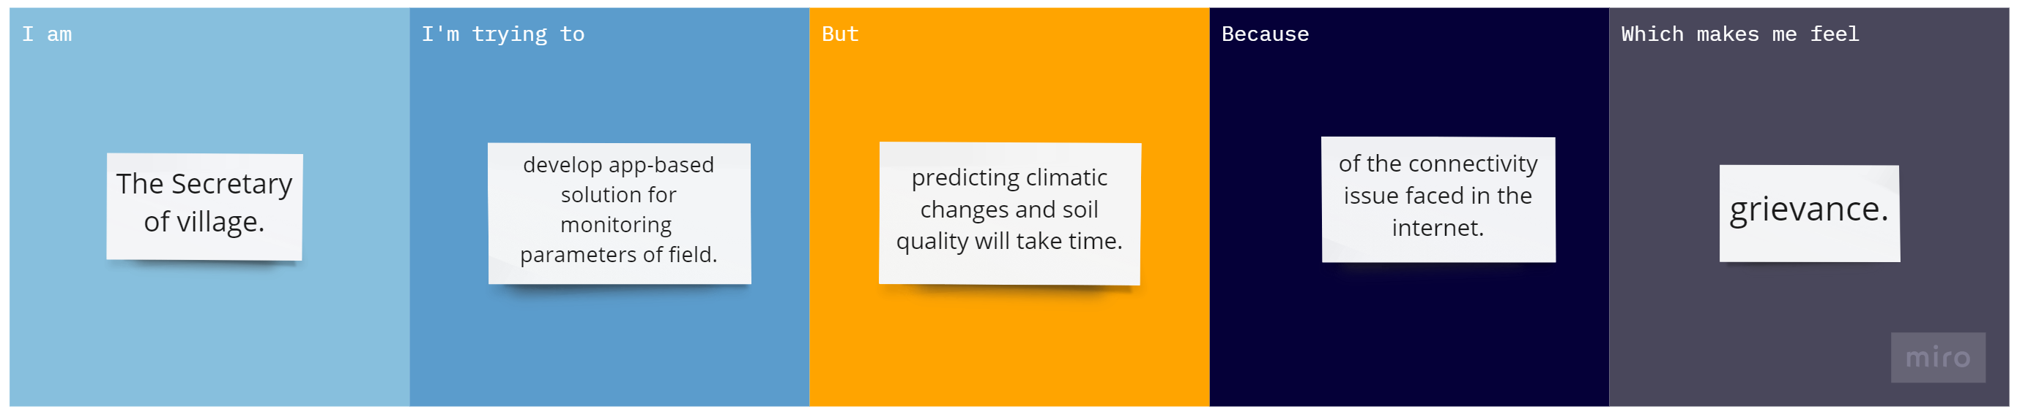

**Problem Statements : IoT Enabled Smart Farming Application**

|  |  |  |  |  |
| --- | --- | --- | --- | --- |
| **Problem Statement** | **Focused Area** | **Objective** | **Expected Output** | **How does it help** |
| Develop affordable app-based solution for Soil health monitoring and suggest which crop to be sown based on it. | Digital Farming. | Provide remedies & alerts on soil deficiencies like Watering for low Moisture level, Fertilizers for Nutrient deficiencies etc. | Create app-based solution to detect soil parameters like moisture content, temperature, relative humidity, nutrient, and provide crop suggestions to be produced based on soil parameters & environment values. | With the help of solution, farmer can plan which crop to take based on soil condition and plan quickly possible remedies for soil deficiencies. |
| Develop smart solution to protect crops from wild animals. | Smart Techniques for Crop Protection & Management. | Provide alerts on any crop damage in case animals destroy crops. | With the help of remote sensing technologies develop crop protection solution from wild animal attacks. | Along with crop loss, landscape loss and due to wild animals-human conflicts, loss of lives of animals & human alerts can be notified for protection. |
| To create affordable IoT based smart hydroponic vertical farming system. | Enhancing Farmer income in off-season using Hydroponic VF System. | Standardize the nutrient uptake of each high value vegetable. | With the help of IoT sensor develop mobile app for monitoring & controlling of various environmental factors like temperature, relative humidity, CO2 concertation, light intensity and quality parameters of solution like pH, total dissolved solid (TDS) etc. | With the help of Hydroponic based Vertical farming (VF), famers can earn money with 80-90% less water, can grow 100% Organic Food, High Yielding in small time, All year-round yielding. |